Subject: History
Year: 9
Half -Term | Autumn 1 | Autumn 2 | Spring 1 | Spring 2 | Summer 1 | Summer 2
Themes/  Content/  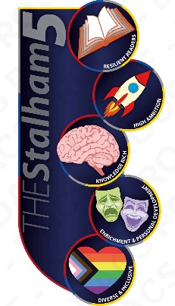  Units covered | Theme: Trade, ideas, and communication  Unit: The Industrial Revolution: did industrialisation revolutionise people’s lives?  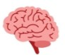  Theme: Empire, persecution, and resistance  Unit: The British Empire: how far was it transformed in the mid-nineteenth century? | Theme: Empire, persecution, and resistance  Unit: The British Empire: how far was it transformed in the mid-nineteenth century?  Theme: Empire, persecution, and resistance  Unit: Interpreting the British Empire: how has it been commemorated and contested?   | Theme: Power, government, and religion  Unit: Women’s suffrage: why did it take so long for women to get the vote in Britain?  Theme: Warfare and conflict  Unit: World War One: how ‘total’ was it for people in the British Empire? | Theme: Warfare and conflict  Unit: World War One: how ‘total’ was it for people in the British Empire?  Theme: Trade, ideas, and communication  Unit: The Russian Revolution: did communism completely transform Russian society? | Theme: Warfare and conflict  Unit: The Second World War: which event turned the tide of the Second World War?  Theme: Empire, persecution, and resistance  Unit: The Holocaust: what was the Holocaust? | Theme: Empire, persecution, and resistance  Unit: The Holocaust: what was the Holocaust?  Theme: Invasion, migration, and settlement  Unit: Post-war Britain: for whom did the United Kingdom become a ‘New Jerusalem’?

