Subject: French
Year:11
Half -Term | Autumn 1 | Autumn 2 | Spring 1 | Spring 2 | Summer 1 | Summer 2
Themes/  Content/    Units covered | 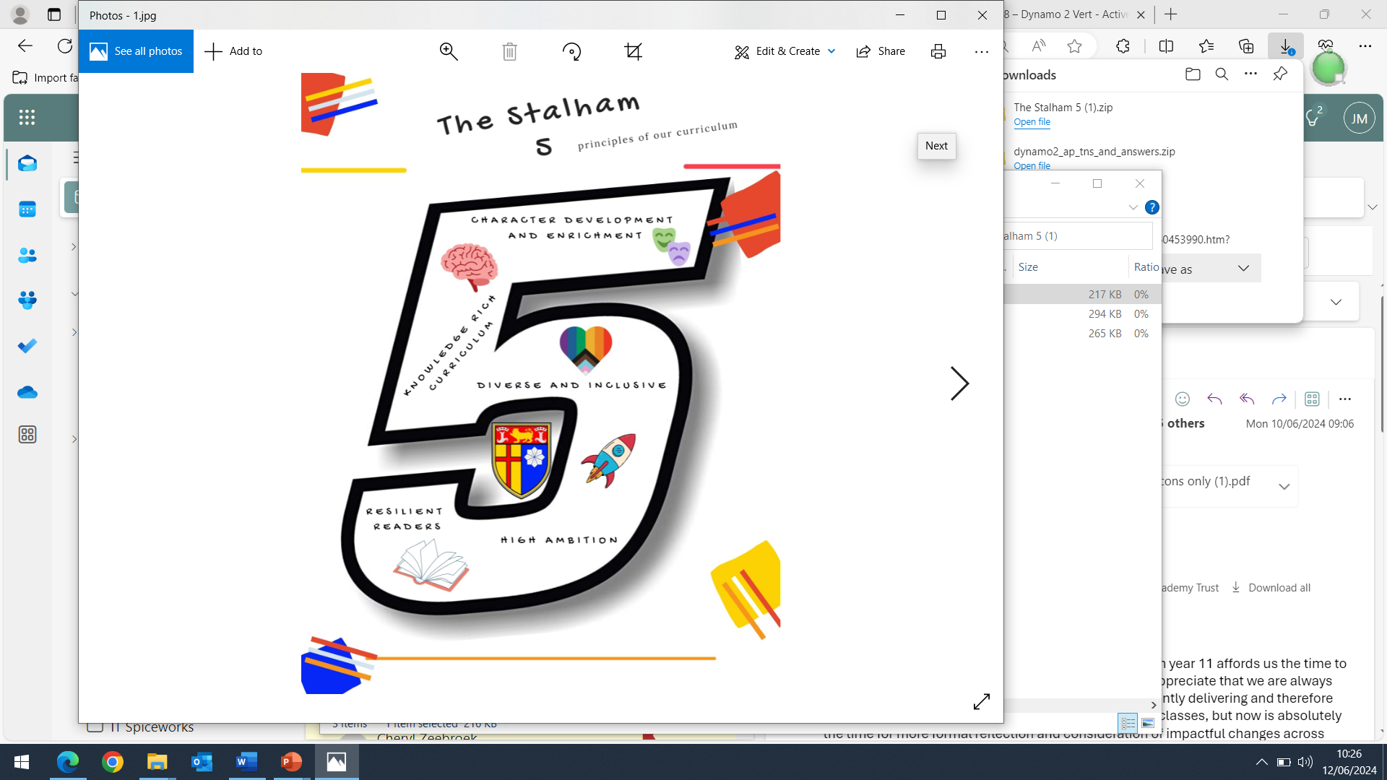  Refer to different routes to fame, including music, film, TV, fashion, culture and technology.  Give opinions on a variety of celebrities.  Understand tips for becoming famous.  Give personal details and describe the abilities and achievements of a variety of famous people.  Refer to articles involving celebrities and influencers, and their impact on young people and wider society.  Refer to the advantages and disadvantages of being famous.  Understand celebrity magazines / articles / podcasts involving famous people and influencers.  Understand what takes place during an international sporting and cultural event: les Jeux de la Francophonie. | Refer to and give opinions on holidays, holiday activities, and weather.  Describe places where we used to live.  Refer to places of interest and different locations including francophone islands across the world.  Refer to recent a holiday, including the destination, transport, activities, and accommodation.  Describe a recent holiday experience, including the destination, location, transport, weather, activities and accommodation. | Refer to all kinds of media, such as the internet and social media, including how they are used and the frequency of use.  Refer to usual and recent uses of the internet, including social media and different apps and platforms.  Give reasons for personal use with advantages and disadvantages.  Give opinions of using mobile phones and different apps.  Refer to technology use in the past, present and future, including frequency of use. | Refer to activities at a local level to help and protect the environment.  Refer to wider global issues causing environmental damage and describe future activities that would make a positive impact on the planet.  Describe your home and activities at home.  Describe your town / village / neighbourhood of residence, including local buildings, activities, and facilities.  Give opinions including advantages and disadvantages for young people and tourists. | REVISION  EXAM PRACTICE | GCSE’s

