Subject: Religion, Self and Society
Year: 8
Half -Term | Autumn 1 | Autumn 2 | Spring 1 | Spring 2 | Summer 1 | Summer 2
Themes/  Content/  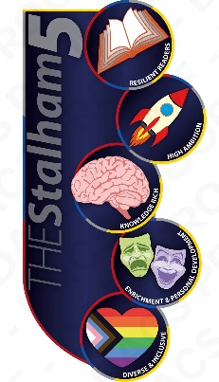  Units covered | Society and Ethics Theme: Emotional Wellbeing    Unit: Brave Together - promoting positive mental health outcomes by improving mental healthy literacy and reducing associated stigma.     | Society and Ethics Theme: Relationships  Unit: RSE – looking at healthy behaviours and expectations in relationships, the spectrum of gender identities and sexual orientations, consent and contraception. | Society and Ethics Theme: Discrimination  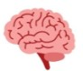  Unit: Belonging & Community – exploring belonging, the impacts of stereotypes, the features and values of respectful inclusive communities, and help to develop understanding of discrimination and extremism. | Society and Ethics Theme: Environment  Unit: Stewardship    Content: Looking at how the Bible teaches about Stewardship, how Christians treat animals and how stewardship is seen in action, with a focus on climate change/plastic problem | Society and Ethics Theme: Healthy Choices  Unit: Drugs and Alcohol - the dangers of alcohol,  smoking and drugs. Pressures relating to drug use, including peer pressure online and offline. | Society and Ethics Theme: Futures  Unit: Community and Careers - equality of  opportunity in careers and life choices.  Different types and patterns of work.

