Subject: Physics
Year: 11
Half -Term | Autumn 1 | Autumn 2 | Spring 1 | Spring 2 | Summer 1 | Summer 2
Themes/  Content/  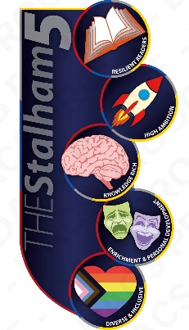  Units covered | Forces  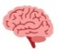  Mass and Weight.      Newton’s laws of motion  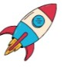  Distance /time graphs | Forces  Hooke’s Law  Resolving vectors  Impact force and momentum | Waves  Types of waves  Electromagnetic waves and their uses  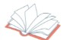  Waves in medicine | Magnetism  Magnetism  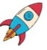  Electro-  magnets  SS Only  Motors, generators, and transformers | SS Only  Space  Stars  Galaxies

