Subject: Physics
Year: 10
Half -Term | Autumn 1 | Autumn 2 | Spring 1 | Spring 2 | Summer 1 | Summer 2
Themes/  Content/  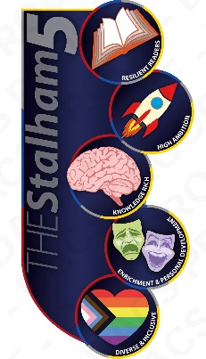  Units covered | Energy resources    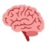  Renewable and non-renewable energy sources    Energy stores  Kinetic energy  Potential energy | Energy Transfers    Specific heat capacity  Insulation    Heating and insulating buildings | Electrical circuits  Electrical charge and current  Ohms law  Electrical components | Domestic electricity  Cables and plug  The national grid  Appliances and their efficiency | The particle model of matter  Changes of state  Density  Gas pressure | Atomic structure  Models of the atom  Radiation  SS Only  Nuclear fission and fusion

