Subject: Computing
Year 9
Half -Term | Autumn 1 | Autumn 2 | Spring 1 | Spring 2 | Summer 1 | Summer 2
Themes/  Content/  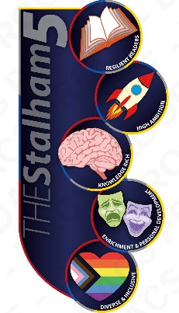  Units covered | 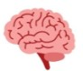  Using count-controlled (for loops) and condition-controlled (while loops) iteration    Combining iteration with selection (if, else, elif statements) to create more complex programs  Working with variables, inputs, and outputs to design programs that solve specific problems |     Applying logical reasoning to predict, test, and evaluate programs, supporting the development of debugging skills  Designing and developing modular programs with clear, maintainable code and appropriate comments | Learn how to convert between positive denary numbers into binary numbers and vice versa.  Learn how to add two binary integers  Understand how NOT, AND & OR gates process their inputs  Work out the output of a logic circuit for a given set of inputs  Explore logic gates, explain their rules and complete their truth table  To be able to create logic diagrams/ circuits for given scenarios | Learn the purpose and use of databases in storing and retrieving data  Understand key concepts such as tables, records, fields, and data types  Use simple SQL commands to retrieve data (SELECT, WHERE, ORDER BY)  Develop problem-solving skills by querying databases to find information | Use Python to create a digital escape room with interactive puzzles  Apply problem-solving skills to design challenges that require computational thinking  Incorporate selection and iteration to create engaging and dynamic gameplay  Test and evaluate digital puzzles, making improvements based on feedback  Develop logical reasoning through coding and debugging | Use Python with Turtle to develop a simple retro game (e. g., Snake, Pong)  Apply creativity by designing visual elements and game mechanics  Learn how to test and debug code to improve game functionality    Explore how to make games user-friendly with clear instructions and feedback

