Subject: French
Year:9

Half -Term | Autumn 1 | Autumn 2 | Spring 1 | Spring 2 | Summer 1 | Summer 2
Themes/  Content/    Units covered | 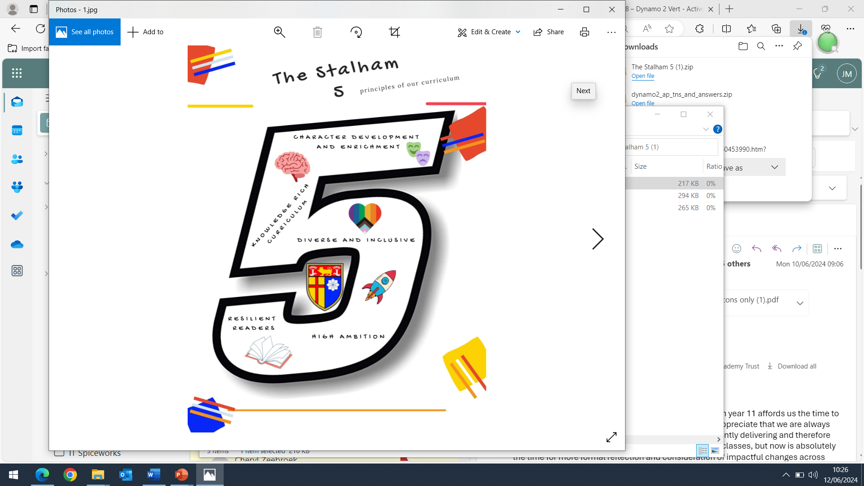  Talking about likes and dislikes  Talking about after school clubs and activities  Describing yourself and your friends  Describing birthday celebrations  Describing what you did and what you wore | Talking about earning money  Talking about what job you want to do and why  Talking about what you are going to do in the future  Talking about what you did yesterday  Talking about different ways of making money | Talking about songs and musical instruments  Discussing musical preferences  Describing future plans  Describing a trip to a concert  Interviewing a young musician | Talking about food  Discussing eating habits  Talking about animals and the natural world  Talking about helping the environment  Talking about what you would like to do | Talking about countries you would like to visit  Describing impressive places  Talking about holiday activities | Preparing a fact file and advert for a French-speaking country  Describing people and what they do  Talking about future plans

