Subject: Science
Year: 9
Half -Term | Autumn 1 | Autumn 2 | Spring 1 | Spring 2 | Summer 1 | Summer 2
Themes/  Content/  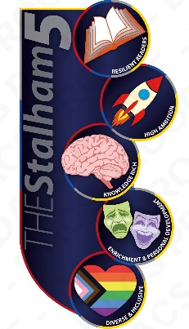  Units covered | Variation for survival    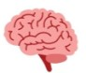  Variation and biodiversity    Genetics and inheritance    Selective breeding and natural selection    Extinction and conservation  Obtaining useful materials  Metal extraction and reactivity  Carbon extraction and mining impact | Obtaining useful materials (cont.)  Chemical reactions and energy changes  Materials and their properties  Motion on Earth and in Space  Motion and graphical representation  Relative motion and forces  Earth’s movement and time measurement  Gravity, orbits and space and the Solar System  Stars and galaxies | Our health and the effects of drugs  Drugs and their effects  Disease  The immune system | Using our Earth Sustainability  The Geosphere  Rocks and the rock cycle  Earth’s atmosphere  Recycling  Waves and Energy and Transfer  Waves  Light | Waves and Energy and Transfer (cont.)  Energy transfer  Practical ecology | Atomic structure  Atomic structure  Electron structure  Development of the periodic table  Energy resources  Renewables  Non-renewables  Energy and the environment

