Subject: Science
Year: 7
Half -Term | Autumn 1 | Autumn 2 | Spring 1 | Spring 2 | Summer 1 | Summer 2
Themes/  Content/  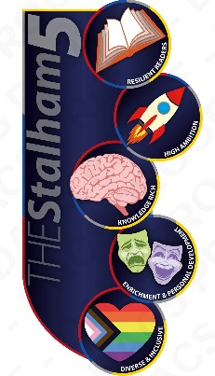  Units covered | Safety in the laboratory  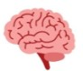    Working safely and scientific equipment  Models in science  Cells and reproduction  use of microscopes.    Using models  Evaluating competing methods    The developing foetus.    Adaptations in plants | Mixing, dissolving, and separating  Properties of substances  Dissolving  Separating mixtures.  Particle model  Chromatography | Forces and their effects  Types of force  Friction and drag  Mass vs. weight  Newton meters  Eating, drinking, and breathing  Healthy diet  Diet imbalance | Eating, drinking, and breathing (cont.)  Gas exchange and diffusion surfaces  Lifestyle and disease impacts  Digestive system  Elements, compounds, and reactions  Developing the periodic table  Properties and features of elements  Naming compounds | Elements, compounds, and reactions (cont.)  Representing chemical reactions  Combustion  Energy stores and transfers  Energy stores  Energy transfer  Work done  Thermal energy  Fuels and energy resources | Energy stores and transfers (cont.)  Sound and waves  Auditory range  STEM Roller coaster project  Teamwork  Problem solving  Design  Hidden Figures  Women in STEM  Diversity in STEM

