Subject: French
Year:8

Half -Term | Autumn 1 | Autumn 2 | Spring 1 | Spring 2 | Summer 1 | Summer 2
Themes/  Content/    Units covered | 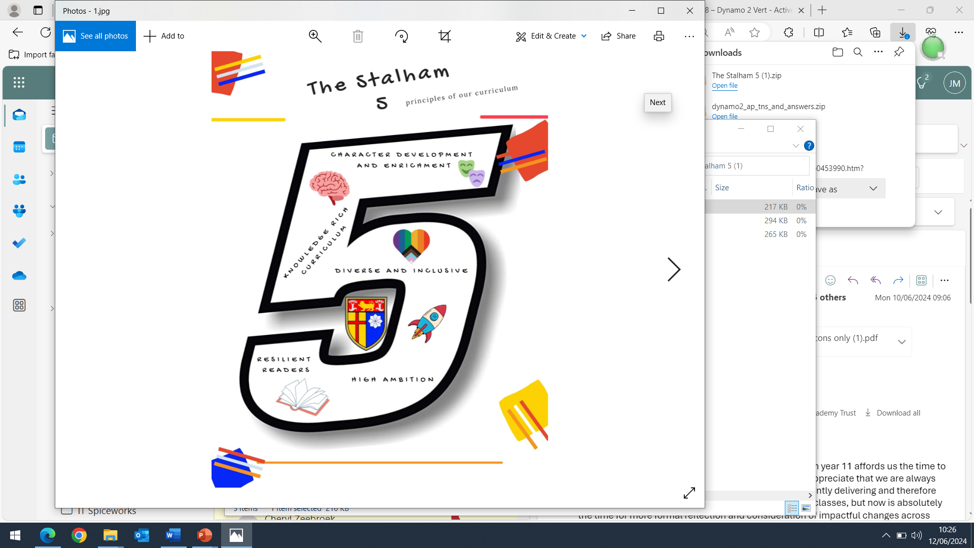  Talking about animals  Using higher numbers  Describing your family  Using possessive adjectives  Describing where you live | Learning about Bastille Day  Creating a cartoon family  Using the nous form of -er verbs | Talking about places in town  Saying where you go at the weekend  Inviting someone out  Using the verb aller (to go)  Using the verb vouloir (to want) | Ordering drinks and snacks in a café  Understanding prices  Saying what you are going to do  Using the tu and vous forms of the verb  Using the near future (aller + infinitive) | Holiday time in the French-speaking world  Talking about the school holidays  Saying what you visited and what it was like  Saying what you did during the holidays | Understanding the perfect tense of irregular verbs  Taking part in an interview about a special holiday

