Subject: Computer Science
Year 10
Half -Term | Autumn 1 | Autumn 2 | Spring 1 | Spring 2 | Summer 1 | Summer 2
Themes/  Content/  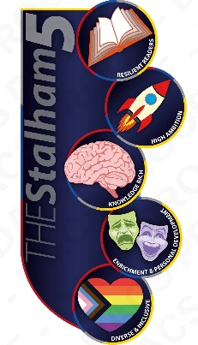  Units covered |   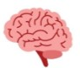  Dismantling a PC to identify hardware inside  Learning about the purpose of the fetch execute cycle  Learning about CPU components and the Von Neuman Architecture    Writing your first programs in Python    Discovering how to debug your own code and identify syntax errors  Using arithmetic and comparison operators in algorithms  Learning about data types and casting in algorithms | Learning about the performance of the CPU  Learning about embedded systems  Learning about primary storage (e.g. ROM, RAM and virtual memory)  Applying sequence in programming  Identifying and using selection in programming  Exploring more complex programs | Learning about secondary storage (e.g. magnetic, optical and solid state)  Tackling a long answer exam question  Learning the units of data capacity  Converting data units (e.g. bytes to kilobytes)  Identifying and using count-controlled iteration  Identifying and using condition-controlled iteration  Programming  project | Learning why computers need to store data in binary  Converting denary to binary numbers and vice versa  Adding 2 binary numbers together  Converting from hexadecimal to binary and vice versa  Converting from denary to hexadecimal and vice versa  Representing algorithms as flow charts and using trace tables  Generating random numbers in programs | Learning how computers process characters  Learning how computers process images  Learning how computers process sound  Learning how compression algorithms are used  Exploring Boolean logic; creating truth tables and designing logic diagrams | Learning string manipulation and applying these to algorithms  Using file handling operations (open, read, write, close)  Using arrays when solving problems  Using programs (functions and procedures) to produce structured code

