Subject: History
Year: 8
Half -Term | Autumn 1 | Autumn 2 | Spring 1 | Spring 2 | Summer 1 | Summer 2
Themes/  Content/  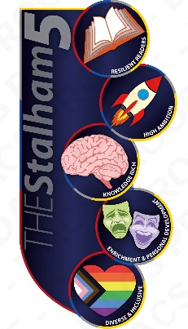  Units covered | Theme: Power, government, and religion  Unit: Henry VIII and the Reformation: how unusual was the English Reformation?    Theme: Power, government, and religion  Unit: Elizabeth I: why has Elizabeth been represented so differently?   | Theme: Power, government, and religion  Unit: Elizabeth I: why has Elizabeth been represented so differently?  Theme: Life in Tudor England: was there a ‘Golden Age’ for the poor? | Theme: Empire, persecution, and resistance: European conquest of the Americas: why was its impact so devastating?  Theme: Power, government, and religion  Unit: The English Civil War: what can pamphlets tell us about 17th century politics? | Theme: Power, government, and religion  Unit: The English Civil War: what can pamphlets tell us about 17th century politics?  Theme: Power, Government, and religion  Unit: The Glorious Revolution: how do historians’ views of it differ? | Theme: Empire, persecution, and resistance  Unit: Transatlantic slavery: how were West African societies impacted?  Theme: Empire, persecution, and resistance  Unit: The Haitian Revolution: what was its role in the abolition of the slave trade? | Theme: Empire, persecution, and resistance  Unit: The Haitian Revolution: what was its role in the abolition of the slave trade?  Trade, ideas, and communication  Unit: The Enlightenment: what was the Enlightenment?

