Subject: Science
Year: 8
Half -Term | Autumn 1 | Autumn 2 | Spring 1 | Spring 2 | Summer 1 | Summer 2
Themes/  Content/  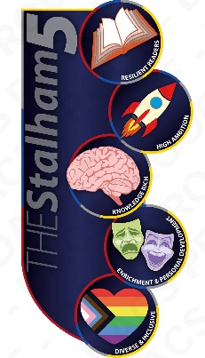  Units covered | Getting the energy your body needs    Skeletal system and muscles  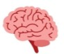  Respiration and breathing  Explaining physical changes  Particle model and states of matter  Changes of state and heating effects    Density, pressure and diffusion  Conservation of mass and chemical reactions |   Exploring contact and non-contact forces  Magnetism and electrostatic forces  Gravity and its effects  Pressure and upthrust | Looking at plants and ecosystems  Plant biology  Ecosystems  Environmental interactions and interdependence  Water and nutrient transport  Bioaccumulation  Extremophiles  Testing a leaf for starch | Explaining chemical changes  Acid, base, alkali  Indicators  Neutralisation  Combustion  Acids and metal reactions | Magnetism and electricity  The history of magnetism  Magnetic fields  Electromagnets | Magnetism and electricity (cont.)  Charge and batteries  Series and parallel circuits  STEM Suncream investigation project  Teamwork and presentation skills  Problem solving  Design an investigation

