Subject: Biology
Year: 11
Half -Term | Autumn 1 | Autumn 2 | Spring 1 | Spring 2 | Summer 1 | Summer 2
Themes/  Content/  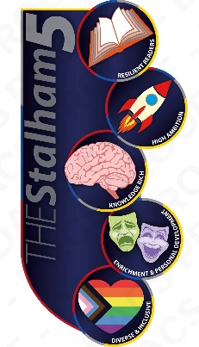  Units covered | Homeostasis and Response    Homeostasis and Negative Feedback Loops    Nervous and Endocrine Systems  SS only:    The Brain, Eye and Kidneys    Human Reproduction and the Menstrual Cycle    Contraception and Treating Infertility    SS only:  Plant Hormones | Inheritance, Variation and Evolution  DNA and the Human Genome  Sexual/Asexual Reproduction and Meiosis  Genetic Inheritance and Genetic Disorders  Variation, Evolution and Extinction  Selective Breeding  Genetic Engineering  Classification  SS Only:  Mendel, Cloning and Speciation | Ecology  Communities and Biodiversity  Practical Ecology  Competition and Adaptation  Feeding Relationships  Carbon and Water Cycle  Pollution and Global Warming  Deforestation and Peat Destruction | Ecology continued (SS only)  Decomposition  Food Security, Efficiency and Sustainability  GCSE Revision | GCSE Revision

