Subject: History
Year: 7
Half -Term | Autumn 1 | Autumn 2 | Spring 1 | Spring 2 | Summer 1 | Summer 2
Themes/  Content/  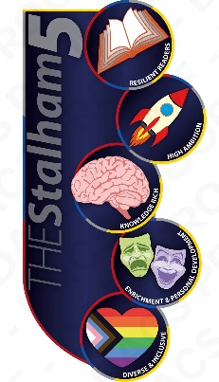  Units covered | Theme: Power, government, and religion  Unit: The Christian Church: how completely did the Great Schism transform Christendom?  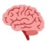  Theme: Trade, ideas, and communication  Unit: 11th century Islamic Worlds: how similar were the regions of the Islamic World?    Theme: Invasion, migration, and settlement  Unit: The Norman Conquest: how do we know about the impact of the Conquest on England?  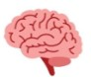 | Theme: Invasion, migration, and settlement  Unit: The Norman Conquest: how do we know about the impact of the Conquest on England?  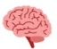  Theme: Warfare and conflict  Unit: The Crusades: did Europeans go on crusade to capture the ‘holy land’? | Theme: Trade, ideas, and communication  Unit: Medieval women: what can we learn from Matilda about women in medieval England?  Theme: Power, government, and religion  Unit: England under Henry II: how successfully did Henry reassert royal authority? | Theme: Power, government, and religion  Unit: England under Henry II: how successfully did Henry reassert royal authority?  Theme: Power, government, and religion  Unit: Magna Carta: how did Magna Carta survive? | Theme: Trade, ideas, and communication  Unit: Local history: how similar were medieval lives in Norwich?  Theme: Trade, ideas, and communication  Unit: The Black Death and the Silk Road: how connected was the medieval world? | Theme: Power, government, and religion  Unit: The Peasants’ Revolt: why do historians disagree about its causes?  Theme: Trade, ideas, and communication  Unit: The Renaissance: what do artefacts of the Renaissance tell us about it?

