Subject: Chemistry
Year:10
Half -Term | Autumn 1 | Autumn 2 | Spring 1 | Spring 2 | Summer 1 | Summer 2
Themes/  Content/  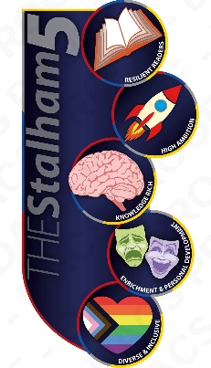  Units covered | Atomic Structure and the Periodic Table    Atoms, Elements and Compounds    Mixtures and separation Techniques    History of the atom    Atomic Structure, Isotopes and Electronic Configuration, groups    Development of the periodic table  Chemical equations  SS ONLY: Transition Metals | Bonding, Structure and Properties of Matter  Ionic bonding, Compounds and Properties  Covalent bonding and properties of simple and giant covalent structures  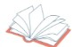  Metallic bonding and alloys  Changes of State  Polymers  SS ONLY: Nanoparticles and applications | Quantitative Chemistry  Relative mass, conservation of mass, balancing and using moles in equations  Limiting reactants  Concentration of solutions  SS ONLY:  Yield and atom economy  SS ONLY: Titrations and calculations  Uncertainty in measurements | Chemical Changes  Displacement reactions and extracting metals  Making salts  pH scale and neutralisation  SS ONLY: Strong and weak acids | Chemical Changes (cont.)  Electrolysis – introduction; products; electrolysis of brine and aqueous solutions and the extraction of aluminium | Energy Changes  Endothermic and exothermic energy changes  Using energy transfers  Reaction profiles  Bond energy calculations  SS ONLY: Chemical cells and batteries and fuel cells

