Subject: Food and Nutrition
Year:10
Half -Term | Autumn 1 | Autumn 2 | Spring 1 | Spring 2 | Summer 1 | Summer 2
Themes/  Content/  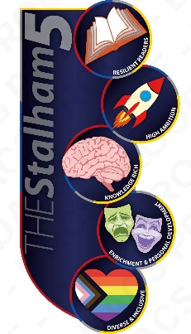  Units covered |     Developing our knowledge of bacteria, food storage and seasonal foods  Learning about fruits and vegetables  Learning about dairy products      Cooking dishes that use fruits and vegetables  Creating dishes that use dairy products  Improving our food science knowledge linked to commodities | Learning about oils, fats and sugars  Cooking dishes that use fats and sugars  Developing our knowledge of core practical skills and cooking techniques  Learning about seasonal food traditions in the UK and creating a range of seasonal Christmas dishes  Developing a knowledge of different methods of heat transfer | Learning about a wide variety of cereals  Learning to make bread and develop our skills in proving and shaping  Cooking a wide variety of cereal based dishes    Working together to help each other in practical lessons | Learning about meat, fish, poultry and eggs  Learning to cook with meat, fish, poultry and eggs  Learning to joint a chicken, portion it and how to cook it in different ways.  Developing our understanding of farming to include organic farming, fair trade  Developing technical skills including choux pastry and pasta | Developing a knowledge of beans, nuts, seeds and alternative proteins  Developing our knowledge of British and International dishes  Development of core theory knowledge | Developing our understanding of the NEA requirements  Practicing a food science investigation and learning about enzymic browning  Developing food presentation skills in particular food styling

