Subject: Religion, Self and Society
Year: 7
Half -Term | Autumn 1 | Autumn 2 | Spring 1 | Spring 2 | Summer 1 | Summer 2
Themes/  Content/  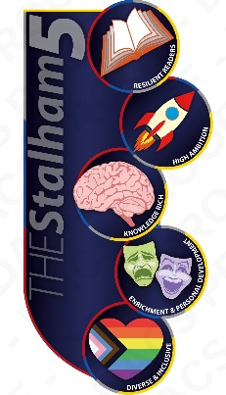  Units covered | Society and Ethics Theme: Transition      Unit: Denominations: why did the Christian Church become diverse? Comparing the different communities within Christianity | Society and Ethics Theme: Relationships      Unit: RSE – including puberty and emotional changes, menstrual wellbeing, healthy and unhealthy relationships, managing conflict and an introduction to consent. | Society and Ethics Theme: Healthy Lifestyles  Unit: How to look out for our physical health – including alcohol, drugs, smoking, diet and exercise and sleep. | Society and Ethics Theme: Community    Unit: Bullying - looking at issues such as banter, bystanders, and self-esteem, and the way in which they relate to bullying. | Society and Ethics Theme: Finance  Unit: Financial decision making - saving  money, borrowing money, budgeting  and making financial choices. | Society and Ethics Theme: Safety  Unit: Digital Literacy – focussing on online safety and how to use social networking sites safely, including age restrictions. Media reliability and gambling hooks in online gaming sites.

