Subject: French
Year:7
Half -Term | Autumn 1 | Autumn 2 | Spring 1 | Spring 2 | Summer 1 | Summer 2
Themes/  Content/  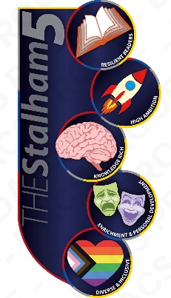  Units covered |   Learning to pronounce French sounds      Giving basic introductory greetings  Talking about brothers and sisters  Describing a classroom    Talking about likes and dislikes | Describing yourself and others  Saying what you do  Creating a video interview about yourself | School in the French-speaking world  Talking about colours  Telling the time    Saying what you think of your school subjects and why  Talking about what you wear to school | Talking about your school day  Learning about a typical French school  Saying what there is/what there isn’t using il y a… and il n’y a pas de … | Sport and leisure activities in the French-speaking world  Talking about weather and seasons  Talking about which sports you play | Discovering sport in French-speaking countries  Talking about what you like doing  Creating an interview with a celebrity

