Subject: Religion, Self and Society
Year: 11
Half -Term | Autumn 1 | Autumn 2 | Spring 1 | Spring 2 | Summer 1 | Summer 2
Themes/  Content/  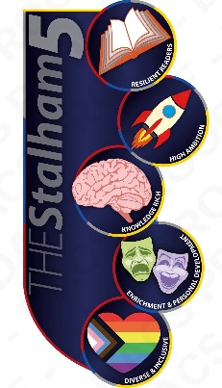  Units covered |   Theme: Gender Stereotypes    Unit: A series of lessons exploring topics such as hobbies, appearance, and careers. Dismantling the gender stereotypes surrounding them. | Theme: Gender Stereotypes  Unit: A series of lessons exploring topics such as hobbies, appearance and careers, dismantling the gender stereotypes surrounding them.  Theme: Crime and Punishment  Unit: Looking at the reasons for crime, the aims of punishment and religious responses to crime. |   Theme: Crime and Punishment      Unit: Looking at the reasons for crime, the aims of punishment and religious responses to crime. | Theme: RSE  Unit: Looking at consent, sex and the media, teen pregnancy, STI’s, contraception and breast/testicular cancer. | Theme: RSE  Unit: Looking at consent, sex and the media, teen pregnancy, STI’s, contraception and breast/testicular cancer.

