Subject: Computing
Year 8
Half -Term | Autumn 1 | Autumn 2 | Spring 1 | Spring 2 | Summer 1 | Summer 2
Themes/  Content/  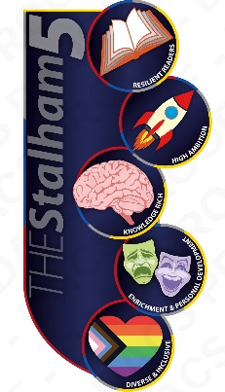  Units covered |     Learn how to use Turtle to create simple shapes and edit the appearance of these (e.g. size, colour, line width)    Use Turtle graphics to create shapes and patterns with iteration  Learn the purpose of variables in programming  Take inputs from a user to create customised programs | Use subroutines in Turtle  Create algorithms using lists  Solve a computational problem (creating a Turtle race game) | Write and execute Python programs    Learn common syntax errors and how to debug programs  Create variables with appropriate naming conventions  Learn how to take inputs from a user and store this in a variable  Use arithmetic operators in Python to perform calculations | Identify the use of selection in programs  Use if, elif and else to create decision paths in a program  Create interactive programs using selection to respond to user input  Learn how to use the random number module in Python  Create interactive games such as ‘rock, paper, scissors’ and ‘guess the number’. | Understanding the basics of computer networks (LAN, WAN, Internet)  Identifying network topologies and hardware (routers, switches)  Exploring the fundamentals of cybersecurity (threats like malware, phishing, and prevention methods) | Learn the basics of web design and development using HTML and CSS  Create simple web pages with headings, text, images, and links  Understand the structure of a website (e.g., header, body, footer)  Use CSS to style web pages and improve design  Develop an understanding of online safety and digital literacy through responsible web publishing

