Subject: Computer Science
Year 11
Half -Term | Autumn 1 | Autumn 2 | Spring 1 | Spring 2 | Summer 1 | Summer 2
Themes/  Content/  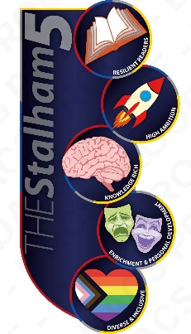  Units covered |   Learning the characteristics of types of network (LANs & WANS)  Identifying factors that can affect network performance  Exploring hardware needed to connect to a network  Learning about the internet    Designing network topologies  Understanding & applying searching & sorting algorithms    Developing programming skills to design a program | Learning about modes of network connection  Learning about encryption  Exploring IP addressing & MAC addressing  Learning about standards & protocols (including layers)  Using SQL to search for data  Understanding defensive design considerations  Identifying and using suitable test data for a given scenario  Developing programming skills to write a program | Learning about threats to computer systems & networks  Identifying & preventing vulnerabilities in computer systems & networks  Learning the purpose & functionality of operating systems  Learning about the different levels of programming languages  Exploring the tools & facilities available in an IDE  Developing programming skills to test & refine a program | Learning the purpose & functionality of utility software    Exploring the impacts of digital technology on society  Exploring legislation relevant to Computer Science  Developing computational thinking skills | Revision and exam technique in preparation for your exam

