Subject: Psychology
Year:10
Half -Term | Autumn 1 | Autumn 2 | Spring 1 | Spring 2 | Summer 1 | Summer 2
Themes/  Content/  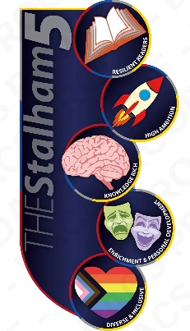  Units covered | Memory    Encoding, storage and retrieval  Different types of memory  The muti-store model  Primacy and recency effects  Bartlett’s ‘War of the Ghosts’ study  Reconstructive memory  Interference/context  False memories      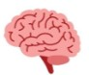   | Perception  Sensation and perception  Visual cues and constancies  Visual illusions  Gibson’s direct theory  Gregory’s constructivist theory  Factors affecting perception | Development  Early brain development  Piaget’s theory  Dweck’s mindset theory  Praise and self-efficacy  Learning styles  Willingham’s learning theory | Research Methods  Hypotheses and variables  Types of experiment  Experimental designs  Sampling methods  Ethics  Interviews and questionnaires  Observation studies  Case studies  Descriptive statistics  Interpretation of data | Social Influence  Ash’s study  Social and dispositional factors  Milgram’s study  Milgram’s agency theory  Adorno’s theory  Prosocial behaviour  Crowd and collective behaviour | Synoptic Revision of Year 10 and gap filling.

